# <Title> (<Sample Name>)

## Introduction

<What programming task does this code sample solve? What specifically does the code sample demonstrate?>

## Building the Sample

<This section is optional. If there are special requirements or instructions for building the sample (e.g. the sample requires certain SDKs), please add this section and illustrate the requirements and steps.>

## Running the Sample

<Describe the demo steps of the sample with screenshots. If there are special requirements for deploying and running the sample (e.g. the sample must be run on Windows 7), please illustrate them in this section too.>

## Using the Code

<How does this sample solve the problem? How can developers probably reuse the sample code? You can insert code snippets and images to make the documentation more illustrative. You must use the OneCode [WordCodeSnippetAddIn](http://sharepoint/sites/onecode/tools/wordCodeSnippetAddIn) to insert uniformly formatted code snippets.>

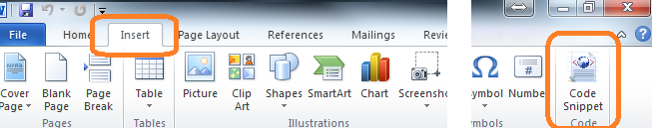

## More Information

<For more information on X, see ...?>